Joshua Trzcienski
COMP 435
LAB 6 Report
Packet Sniffing and Spoofing
Task 1.1: Sniffing Packets
1.1A
In 1.1A, 10.9.0.5 was pinged once, as seen in Image Two, and in a separate terminal task-1.1A.py was run, and in Image One is the captured packet that it picked up. The captured packet happened when task-1.1A.py was run with root, but when the same program was run without root, it was not able to run, seen in Image Three. The error that was given was Operation Not Permitted, and without running with root privilege, it could not capture any packets.
Image One
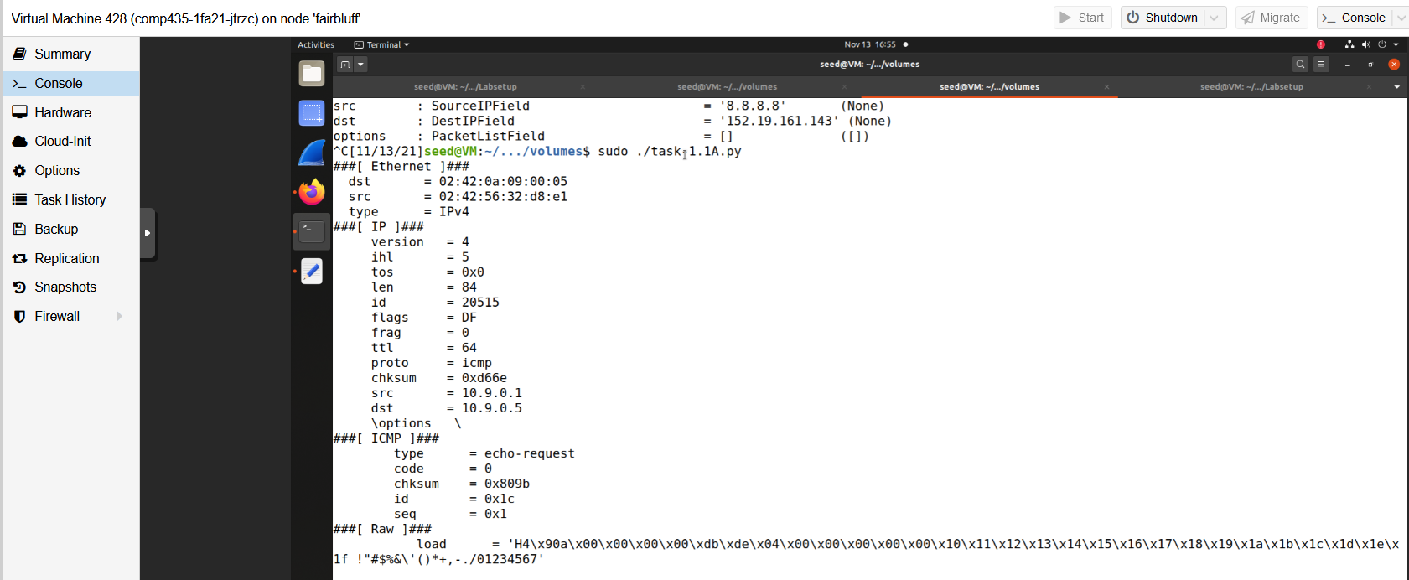
Image Two
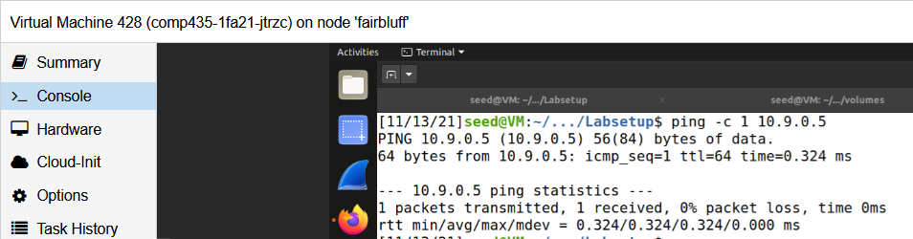
Image Three
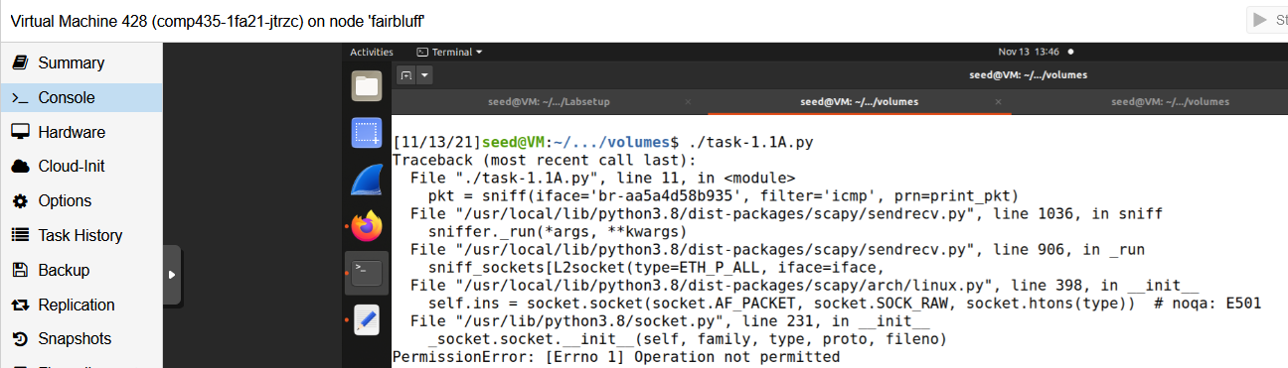
1.1B:
In 1.1B, now instead of the packet filtering only being set to ICMP, there are changes being made. The first filter was to capture any TCP packet that came from 10.9.0.1 with a destination port of 23. The filter used can be seen in Image Four, with Image Five showing the result when task-1.1B.py being run at the same time as the telnet command being run simultaneously, which is Image Six. Telnet is used to make a connection to TCP ports, and its default it port 23, so this is why it is used. Part 2 involved capturing all packets that come from or go to the subnet 10.9.0.0/24. The change to the filter can be seen in Image Seven, and one of the responses can be seen in Image Nine. The difference between this filter and 1.1A is that this filter will show more than just ICMP packets, and this one will show more than ICMP, for example Image Nine shows an ARP packet.
Image Four
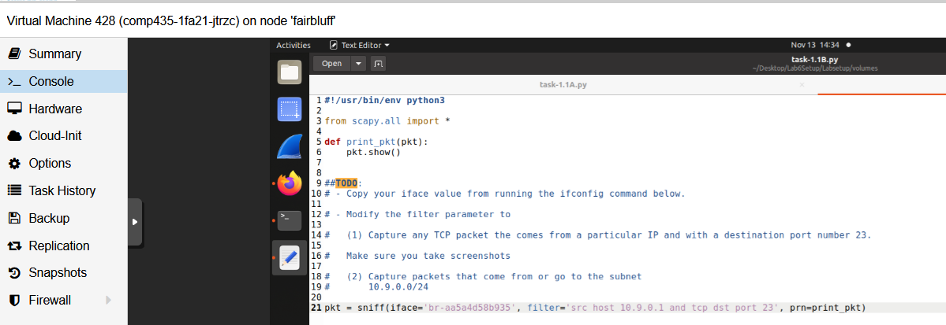
Image Five
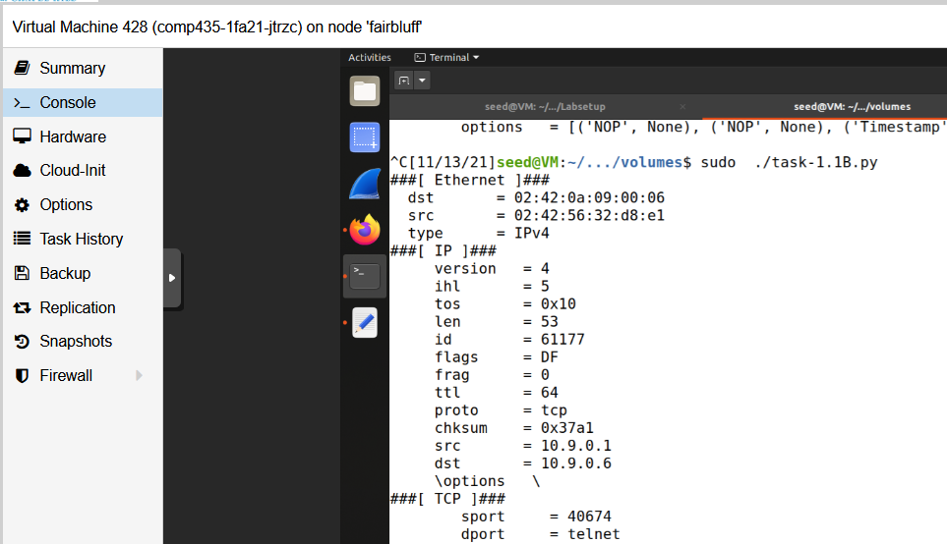
Image Six
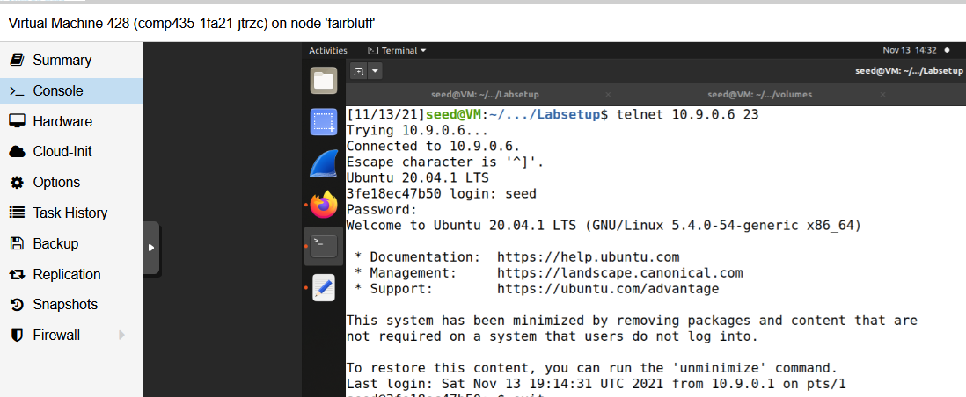

Image Seven
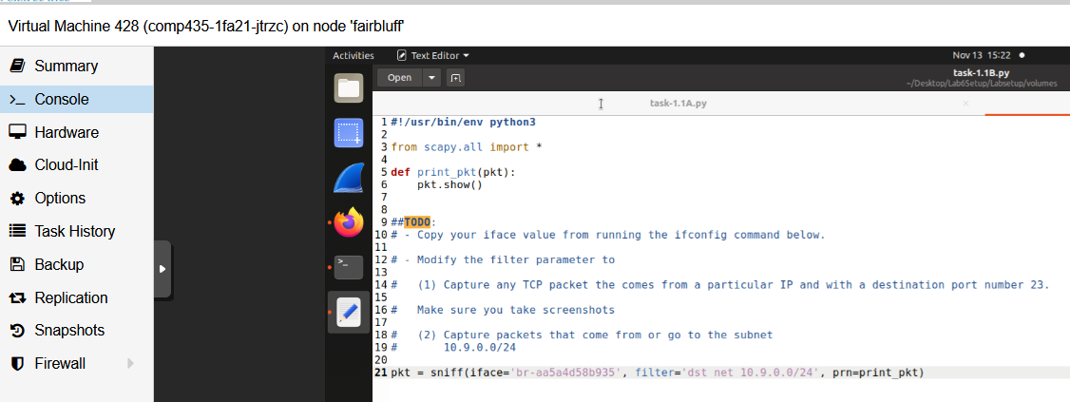
Image Eight
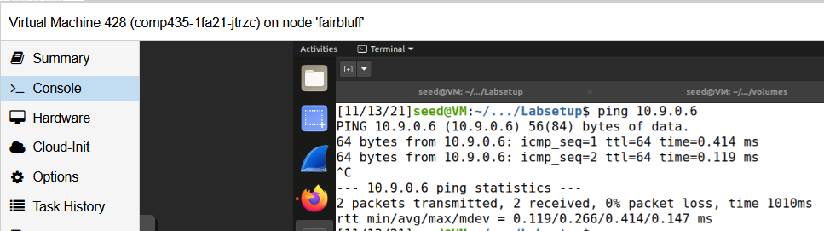

Image Nine
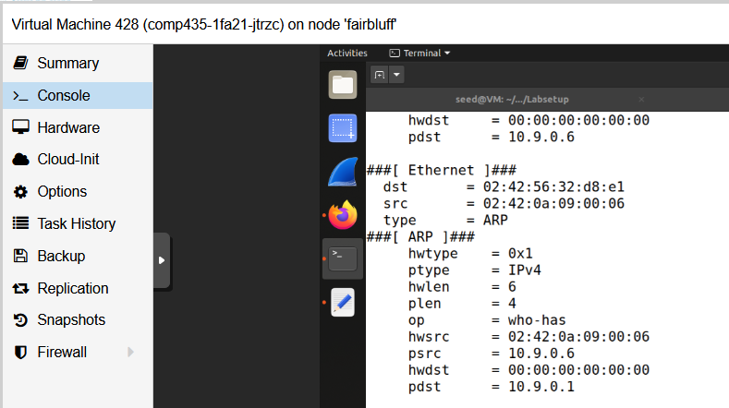
Task 1.2: Spoofing ICMP packets
Image Ten shows the python code that was used in the interactive python session, and the ls(a) command shown after to show the spoofed packet. Below in Image Eleven it shows task-1.1A.py being run at the same time picking up the spoofed packet.
Image Ten
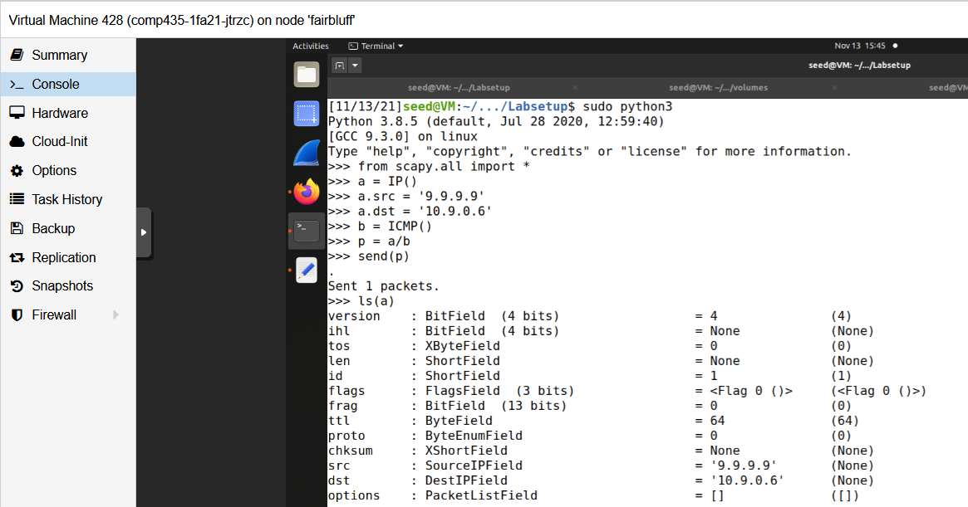
Image Eleven
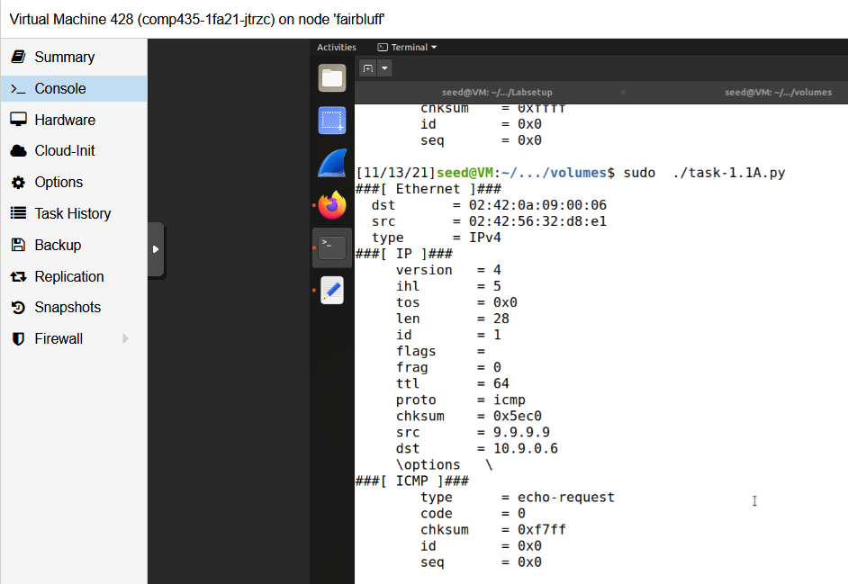
Task 1.3: Traceroute
Task 1.3 involved figuring out how many routers or hops it would take to get to the wanted destination, in this case google.com. After trial and error, the upper bound, seen in Image Twelve, was set to 17, and the amount of hops it took was 16 to get to the final destination seen in Image Thirteen.
Image Twelve
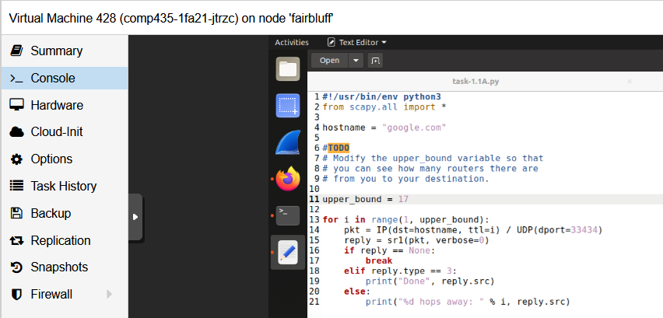
Image Thirteen
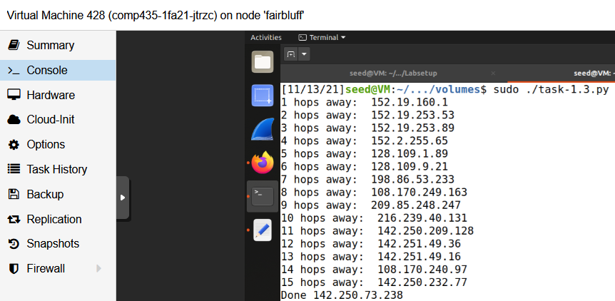
Task 1.4: Sniffing then Spoofing
The first part of the code is actually using scapy to sniff the packet and save it, similar to examples above. The packet was named packet, and can be seen in line 13 where it is declared. The packet is then defined in a function called spoof_packet where the actually spoofing will be done. The next line is an if statement, and the purpose of this is to see if this is an ICMP echo request, which is why it is == 8 because the value of the ICMP echo request is 8. If the packet that was sniffed is an ICMP echo request, go into the if statement where if will then set up a spoofed packet to be sent out automatically. Line 6 is the start of the creation of the spoofed packet. The three headers to be set for the IP field are the src, dst, and ihl which are source, destination, and the size. Because it is an echo reply, the source and destination are flipped from the original packet, but the ihl which is the size should stay the same. The next line is the ICMP field, and the type is set to 0 because that is the value for an echo reply which is what is being spoofed. The id and sequence number are going to be the same because this is an echo reply, so these can be directly taken from the original request packet. After this, the data needs to be copied from the request packet, and it all needs to be included in the reply packet so it is going to be added to the end of the packet which can be seen in line 8. It is all added together like in previous examples and the newpacket which is the spoofed packet is sent out. The results from pinging the three IPs can be seen in Image Fifteen.
Image Fourteen
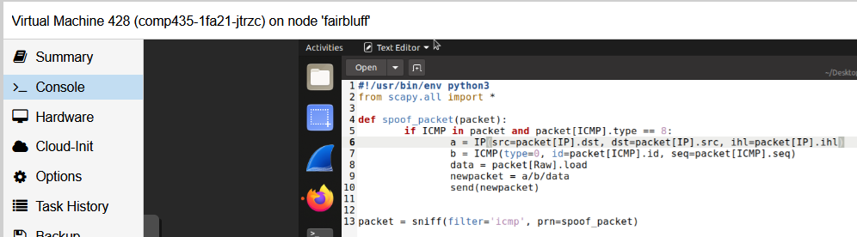

Image Fifteen
